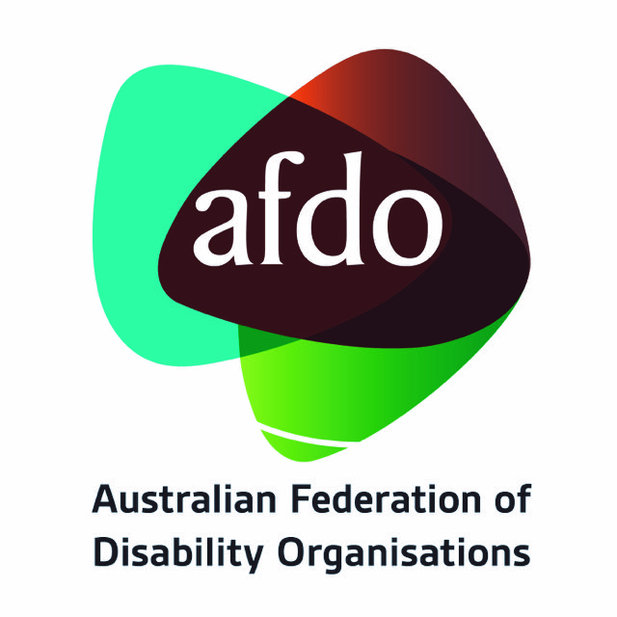 Media release

Budget Fail for Australians with Disability

A sprinkling of cost-of-living relief, for some, is an inadequate Budget response to the significant challenges and major reforms facing people with disability, their families and communities right now and into the foreseeable future.
“There are whole areas that are just missing in action for people with disability,” says Australian Federation of Disability Organisations (AFDO) Chief Executive Officer, Ross Joyce, ‘’And that’s an incredibly disappointing missed opportunity for this government.”

Joyce continued, “Whilst there is some cost-of-living relief with a tax reduction (for those employed), a one-off energy rebate (for those with homes), a meagre increase on rental assistance (for those stuck in rentals) and some cheaper medicines the big-ticket items deliver very little”

It’s estimated there are 200,000 people with disability who are denied access to the Disability Support Pension (DSP) and are relegated to the substantially lower JobSeeker payment. In addition, those who do receive the below-the-poverty line DSP last received a mere $1.40 a day increase for a single rate in April, well below the runaway cost of living expense. There is nothing in this budget that addresses these ongoing inequities, further relegating Australians with disability to a lifetime of entrenched disadvantage.

AFDO President, Grant Lindsay noted, “A person with disability has a daily impact from cost-of-living pressures far greater than those without a disability. It costs more to live with a disability and despite our Members continued advice the Government has again failed to recognise the obvious.”

There are also no additional funds to support people with disability and their advocacy organisations such as AFDO and our Members to undertake significant work on the biggest reforms to their lives since the introduction of the National Disability Insurance Scheme.

Lindsay added, “Beyond the Budget areas we have no funds to do the enormous work needed on the recommendations from both the Disability Royal Commission and the NDIS Review, with this funding increase called for by the Disability Royal Commission, and to cap this off the Government is still sitting on its hands on its responses to both. The use of terms like co-design and consultation begin to feel like just more throwaway lines.”

AFDO and our Members are tired of the National Disability Insurance Scheme (NDIS) and associated measures being depicted negatively, focusing on "cost blowout" and "economic burden." This simplistic framing overlooks the positive outcomes of investing in timely disability supports, its contribution to Australia’s economic growth, plus real savings across health, mental health, aged care and allowing family carers to participate in employment now actively.

Restriction on the funding levels for the NDIS is a serious concern in terms of impacts for participant’s plans and supports then added to when there are significant new funds worth $83.9 million being thrown at fraud control. This is something AFDO and our Members expected, like every other government program including pensions and benefits, would be already built into its staffing, risk management and compliance resources from the outset. These funds could be better utilised elsewhere to support people with disability.

While AFDO welcomes measures to address male violence/violence against women we note there were no specific interventions for women with disability despite them being twice as likely to experience domestic violence than women without disability

AFDO maintains that another revamp of the Disability Employment Service costing $227.6 million next year, will just further up end people with disability and will still not shift their employment participation rate which hasn’t moved for the last twenty-five years and is not money well spent.

While acknowledging some positive aspects, AFDO rates this budget as a failure for people with disability, underscoring the urgent need for meaningful reform and genuine support for the disability community.

For more information, contact;

AFDO CEO, Ross Joyce on 0402 842 040.

AFDO President, Grant Lindsay on 0422 228 467

About AFDO
The Australian Federation of Disability Organisations (AFDO) is a Disabled People’s Organisation (DPO) run by and for people with disability, reaching over 4 million Australians. We are a unique representative organisation covering both disability specific and population-based disability communities and the pre-eminent national voice representing people with disability across Australia and internationally.
Our Members are 36 national and state disability advocacy organisations run by and for people with disability and their families, representing Australians with disability. Our vision is “That all people with disabilities must be involved equally in all aspects of social, economic, political and cultural life.”

Our Members:
Advocacy for Inclusion Inc. – ACT | Arts Access Australia
Autism Aspergers Advocacy Australia | Blind Citizens Australia
Brain Injury Australia | Deaf Australia
Deafblind Australia | Deafness Forum Australia
Disability Advocacy Network Australia | Disability Justice Australia
Disability Resources Centre – Vic | Down Syndrome Australia
Enhanced Lifestyles – SA | Physical Disability Australia
People With Disabilities WA | Polio Australia
South West Autism Network – WA | Women With Disabilities ACT
Women with Disabilities Victoria | National Mental Health Consumer & Carer Forum
Advocacy WA | All Means All
AED Legal Centre – Vic | AMAZE – Vic
Arts Access Victoria | Aspergers Victoria
Disability Advocacy & Complaints Service - SA | Explorability Inc – SA
Multiple Sclerosis Australia | Leadership Plus – Vic
National Union of Students - Disabilities Dept. | National Organisation for Fetal Alcohol Spectrum Disorder
TASC National Limited | Star Victoria Inc
Youth Disability Advocacy Service - Vic | Tourettes Syndrome of Australia

